WORK-CASE №6

***Виконали студенти Горохов Д. та Корольов Є.***

1. В робочому просторі операційної системи необхідно встановити декілька командних інтерпретаторів (окрім bash ще 2 на ваш вибір):  
   - Якими командами це можна зробити;  
   - Опишіть коротко можливості кожного з них.

In addition to bash, I decided to install the zsh and fish command interpreters.

To install, prescribe the commands:



Zsh is one of the modern UNIX shells, used either directly as an interactive shell or as a script interpreter. Zsh is an extended counterpart, and is also backward compatible with the bourne shell, with many improvements.

The first version of zsh was written by Paul Falstad in 1990 when he was a student at Princeton University. The name zSH came from a university assistant named Zhong Shao. Paul thought Zhong's account, “zsh”, would be a good name for a shell. Now developed by enthusiasts, under the direction of Peter Stephenson as part of the free project.

Some useful features:

* programmable autocomplete, which helps users enter both commands and their arguments, with built-in support for several hundred commands;
* shares command history between all running instances of the shell;
* advanced file name completion, which allows you to specify a file without having to run external programs like find;
* extended support for variables and arrays;
* editing multi-line commands in a single buffer;
* typo correction;
* has various compatibility modes (i.e. you can use zsh instead of bourne shell when running as /bin/sh);
* modifiable prompts, including the ability to place the prompt on the right side and to customize auto-open when typing long commands;

Fish is a POSIX-incompatible command shell for Unix-like operating systems. Its distinctive features include syntax highlighting and advanced autocompletion.

Also in fish the syntax of the shell's command language has been simplified, in particular, all control constructs are uniformly terminated with the keyword end.

Another innovation of fish is the so-called universal variables, entered using a construct like set -U variable value. Such variables are shared between all instances of fish on a given computer and allow to exchange information between them.

***Виконав студент Горохов Д.***

1. Необхідно створити 10 нових користувачі в вашій системі та розподілити їх по групам:  
   - Technical support (технічна підтримка, системні адміністратори);  
   - Developers (розробники, технічні спеціалісти свого профілю);  
   - Financiers (бухгалтерія, економісти тощо);  
   - Founders (керівництво);  
   - Guests (гості).

Let's create groups (to do this, use the sudo groupadd group_name command):

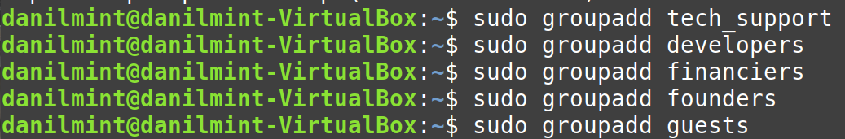

1. Для кожного з користувачів визначити його командний інтерпретатор за замовчуванням:  
   - Technical support – bash;  
   - Developers – командний інтерпретатор 1 (завдання 1);  
   - Financiers – заборонити доступ до командних інтерпретаторів;  
   - Founders – командний інтерпретатор 2 (завдання 1);  
   - Guests – заборонити доступ до командних інтерпретаторів.

Let's create users and assign them to the group (to do this, use the command sudo useradd -m -s, immediately assign them a command interpreter as specified in the task) :

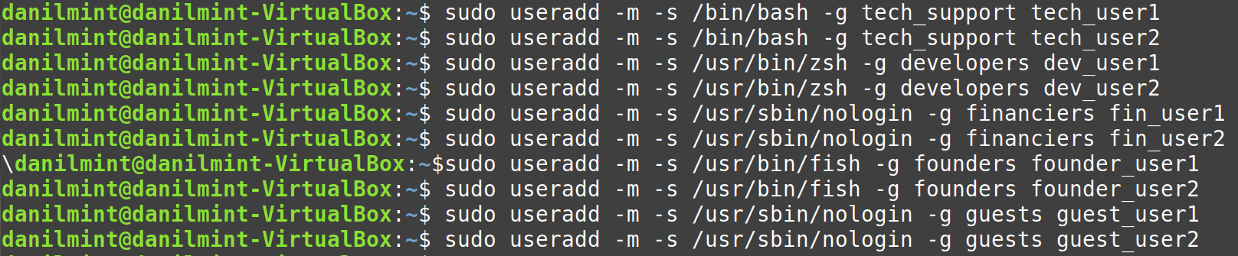

**sudo**:

Executes a command with root privileges.

This is necessary because creating a new user is an operation that requires elevated privileges.

**useradd**:

A basic command to create a new user on Linux.

It creates an entry for the new user in system files such as /etc/passwd and can configure the initial account settings.

**-m**:

This option creates a home directory for the new user.

The directory will be located in /home/user_name by default and will contain the initial configuration files for the user.

If the -m flag is not used, the home directory will not be created automatically.

**-s /usr/bin/fish**:

Specifies the default shell for the user.

/usr/bin/fish is the path to the Fish Shell (an interactive command-line shell) that will be launched when the user logs in.

Fish is a user-friendly shell that supports autocomplete, syntax color highlighting, and other features.

**-g group**:

Specifies the primary group for the user.

group is the group to which the new user_name user will be added. This group must be created in advance.

The master group defines the user's initial access rights to the group shares.

**user_name**:

The name of the new user.

This value indicates the user account that will be created on the system.

1. fПродемонструвати приклади роботи кожної групи користувачів у своєму командному інтерпретаторі – наприклад збір відомостей про систему, визначення базової конфігурації, системної дати, поточних каталогів тощо.

To see the execution process for users, I will set a password (to be able to log in with an account). After that, you must log out of our account and log in as a new user.

User passwords:

For tech_user1 = 11111

For dev_user1 = mynameisdanil

For founder_user1 = 22222

For fin_user1 = 33333

To log in to your account, use the command: su – user_name.

Bash(tech_user1):

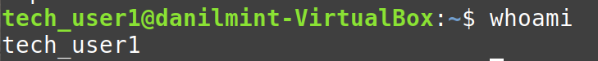

Displays the name of the current user.

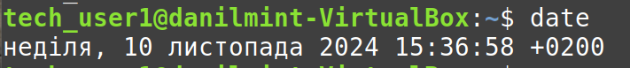

Current date.



System Information.

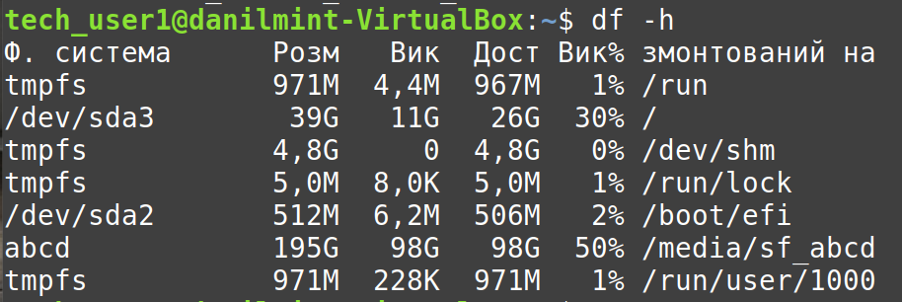

Disk space information.

Zsh(dev_user1):

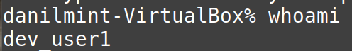

Displays the name of the current user.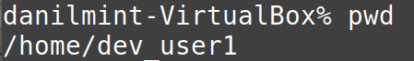

Current directory.

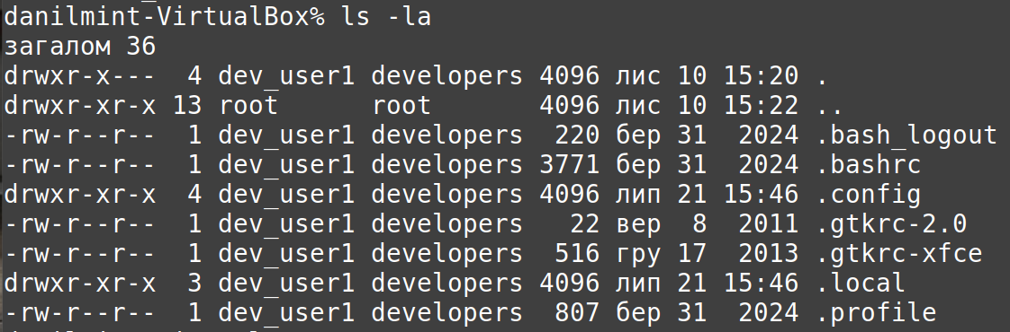

View files in the current directory.

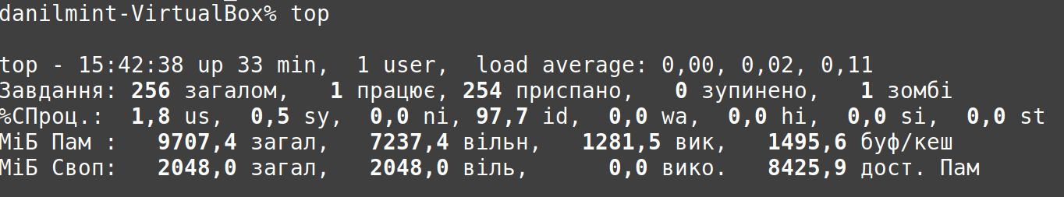

Output of current processes.

Fish(founder_user1):



Displays the name of the current user.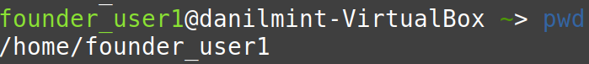

Current directory.

Operating time of the system.



The size of the home directory.

Financiers and Guests do not have access to the command interpreter, so on the login screen you can see:

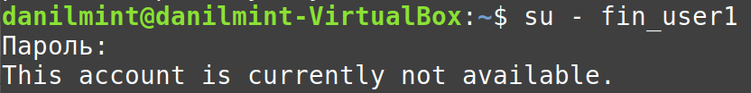

To exit, use the exit command. This command will revert to the administrator or previous user account.

